External Tangency

Definition
# Source: AI Source: Provided by: [Data Path: Persons Table -> ID Column: 1, Name_En Column: Motasem Essam] -> From: [ChatGPT] on [7/25/2026]
External Tangency is a type of Circle–Circle Tangency in which two distinct circles lie outside each other and touch at exactly one common point.
That common point is called the Tangency Point or Point of Tangency.
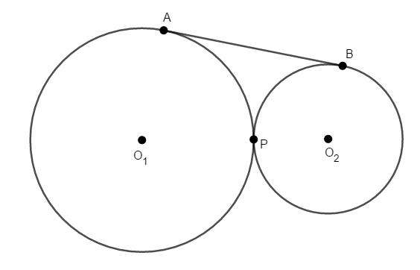
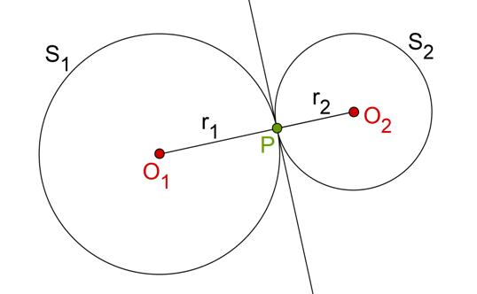
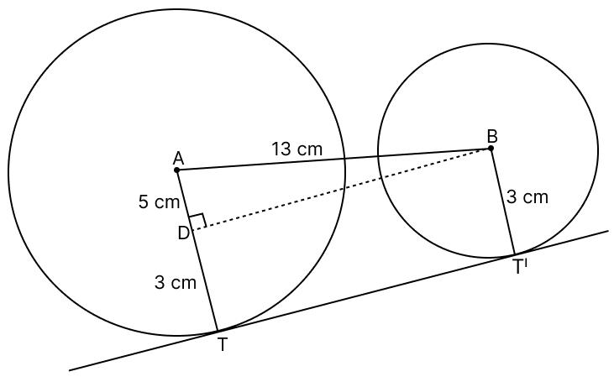
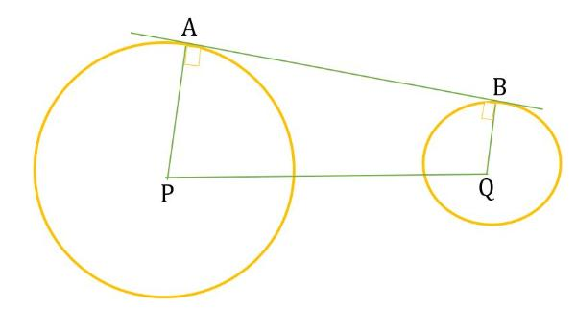

Fundamental Concept
# Source: AI Source: Provided by: [Data Path: Persons Table -> ID Column: 1, Name_En Column: Motasem Essam] -> From: [ChatGPT] on [7/25/2026]
Consider two circles:
- Circle $C_{1}$, with center $O_{1}$and radius $R_{1}$
- Circle $C_{2}$, with center $O_{2}$and radius $R_{2}$
- $T$, their tangency point
For external tangency:
$$\boxed{O_{1}O_{2}=R_{1}+R_{2}}$$
The distance between the centers equals the sum of the two radii.
The circles have exactly one common point:
$$\boxed{C_{1}∩C_{2}=\left\{T\right\}}$$

Geometric Configuration
# Source: AI Source: Provided by: [Data Path: Persons Table -> ID Column: 1, Name_En Column: Motasem Essam] -> From: [ChatGPT] on [7/25/2026]
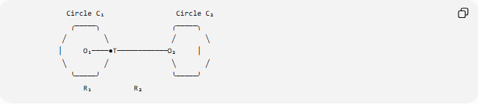
Circle C₁ Circle C₂
╭─────╮ ╭─────╮
╱ ╲ ╱ ╲
│ O₁────●T────────────O₂ │
╲ ╱ ╲ ╱
╰─────╯ ╰─────╯
R₁ R₂
The three points are collinear:
$$\boxed{O_{1}, T, O_{2}\text{ are collinear}}$$
and:
$$O_{1}T=R_{1} \\ TO_{2}=R_{2}$$
Therefore:
$$O_{1}O_{2}=O_{1}T+TO_{2}$$
so:
$$\boxed{O_{1}O_{2}=R_{1}+R_{2}}$$

Tangency Point
# Source: AI Source: Provided by: [Data Path: Persons Table -> ID Column: 1, Name_En Column: Motasem Essam] -> From: [ChatGPT] on [7/25/2026]
The point $T$is the unique point where the two circles touch.
It lies on the line joining the two centers.
For external tangency:
$$\boxed{T∈\overset{‾}{O_{1}O_{2}}}$$
and:
$$\boxed{O_{1}T=R_{1}, O_{2}T=R_{2}}$$
Thus, the tangency point divides the center-to-center segment into two parts equal to the radii.

Center-Distance Condition
# Source: AI Source: Provided by: [Data Path: Persons Table -> ID Column: 1, Name_En Column: Motasem Essam] -> From: [ChatGPT] on [7/25/2026]
Let:
$$d=O_{1}O_{2}$$
Then the condition for external tangency is:
$$\boxed{d=R_{1}+R_{2}}$$
This is the defining distance relationship.
Comparison
$$d>R_{1}+R_{2}$$
→ circles are separated.
$$d=R_{1}+R_{2}$$
→ external tangency.
$$d<R_{1}+R_{2}$$
→ the circles are close enough that they may intersect or one may contain the other, depending on the radii.

Common Tangent at the Tangency Point
# Source: AI Source: Provided by: [Data Path: Persons Table -> ID Column: 1, Name_En Column: Motasem Essam] -> From: [ChatGPT] on [7/25/2026]
At the external tangency point $T$, the two circles have the same tangent line.
The common tangent is perpendicular to the line joining the centers:
$$\boxed{l⊥O_{1}O_{2}}$$
Since $O_{1}T$and $O_{2}T$lie on the same line:
$$\boxed{l⊥O_{1}T}$$
and:
$$\boxed{l⊥O_{2}T}$$
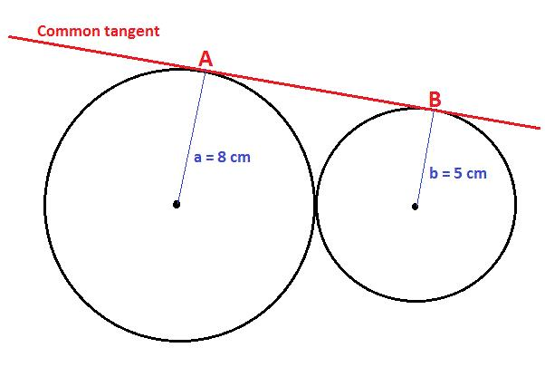
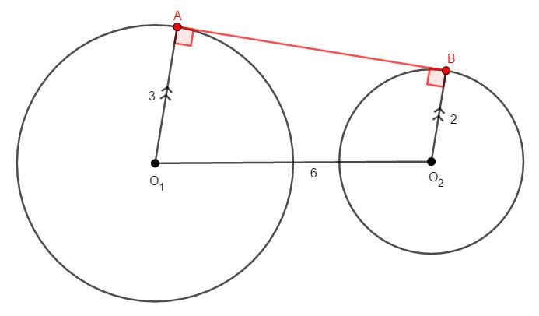
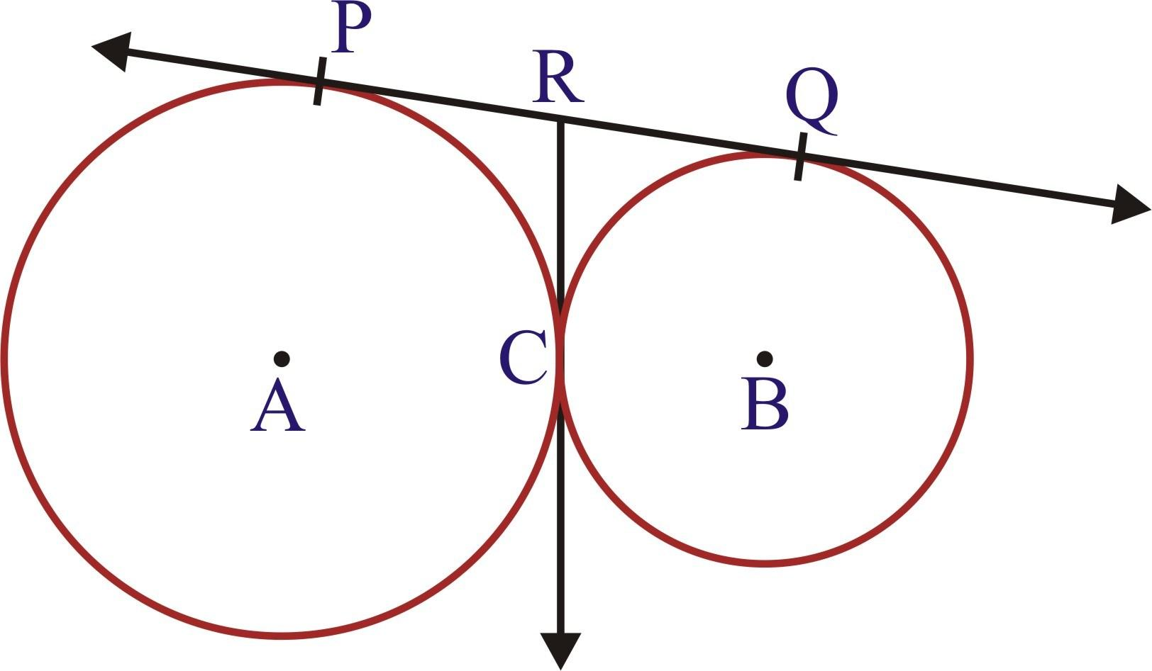
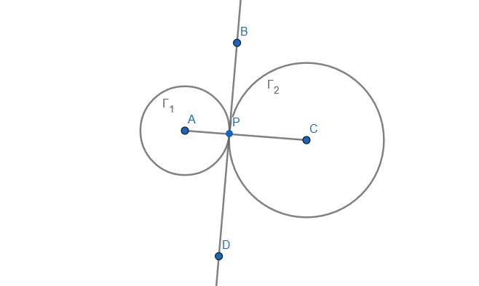
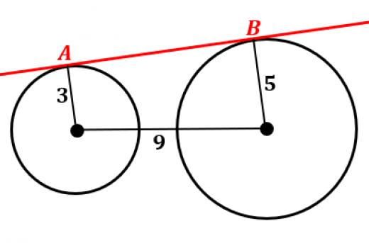

External Tangency vs. Intersection
# Source: AI Source: Provided by: [Data Path: Persons Table -> ID Column: 1, Name_En Column: Motasem Essam] -> From: [ChatGPT] on [7/25/2026]
Two circles normally can have:
- 0 common points;
- 1 common point;
- 2 common points.
External tangency is the special one-point case where the circles touch externally.

Separated Externally Tangent Intersecting

○ ○ ○●○ ╭─╮
╲╱
╱╲
╰─╯
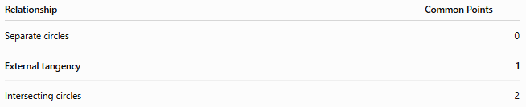
Relationship | Common Points
Separate circles | 0
External tangency | 1
Intersecting circles | 2

Example
# Source: AI Source: Provided by: [Data Path: Persons Table -> ID Column: 1, Name_En Column: Motasem Essam] -> From: [ChatGPT] on [7/25/2026]
Two circles have radii:
$$R_{1}=8\text{ cm}$$
and:
$$R_{2}=5\text{ cm}$$
For external tangency:
$$O_{1}O_{2}=R_{1}+R_{2} \\ O_{1}O_{2}=8+5$$
Therefore:
$$\boxed{O_{1}O_{2}=13\text{ cm}}$$
The tangency point lies between the two centers.

Finding a Missing Radius
# Source: AI Source: Provided by: [Data Path: Persons Table -> ID Column: 1, Name_En Column: Motasem Essam] -> From: [ChatGPT] on [7/25/2026]
Suppose the distance between the centers is:
$$O_{1}O_{2}=20\text{ cm}$$
and one radius is:
$$R_{1}=12\text{ cm}$$
For external tangency:
$$20=12+R_{2}$$
Therefore:
$$R_{2}=8\text{ cm} \\ \boxed{R_{2}=8\text{ cm}}$$

Equal Circles
# Source: AI Source: Provided by: [Data Path: Persons Table -> ID Column: 1, Name_En Column: Motasem Essam] -> From: [ChatGPT] on [7/25/2026]
If the two externally tangent circles have equal radii:
$$R_{1}=R_{2}=R$$
then:
$$O_{1}O_{2}=R+R$$
so:
$$\boxed{O_{1}O_{2}=2R}$$
The tangency point is exactly halfway between the centers:
$$\boxed{O_{1}T=TO_{2}=R}$$
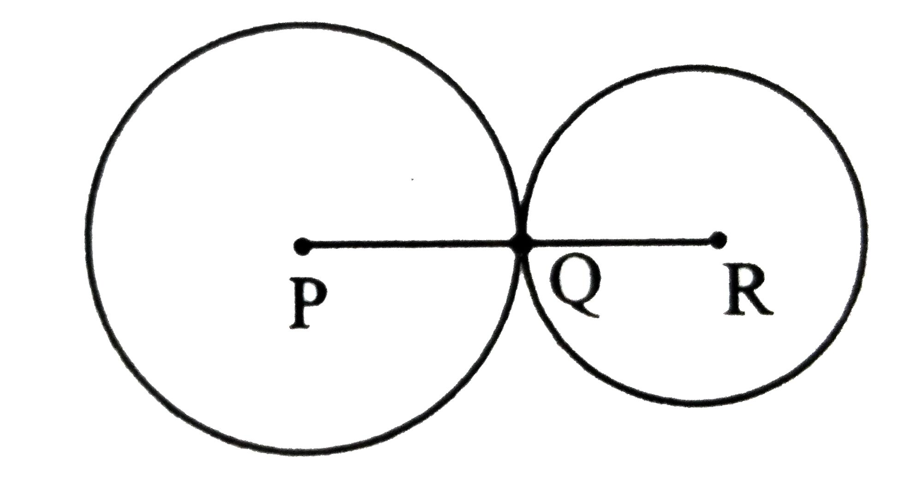
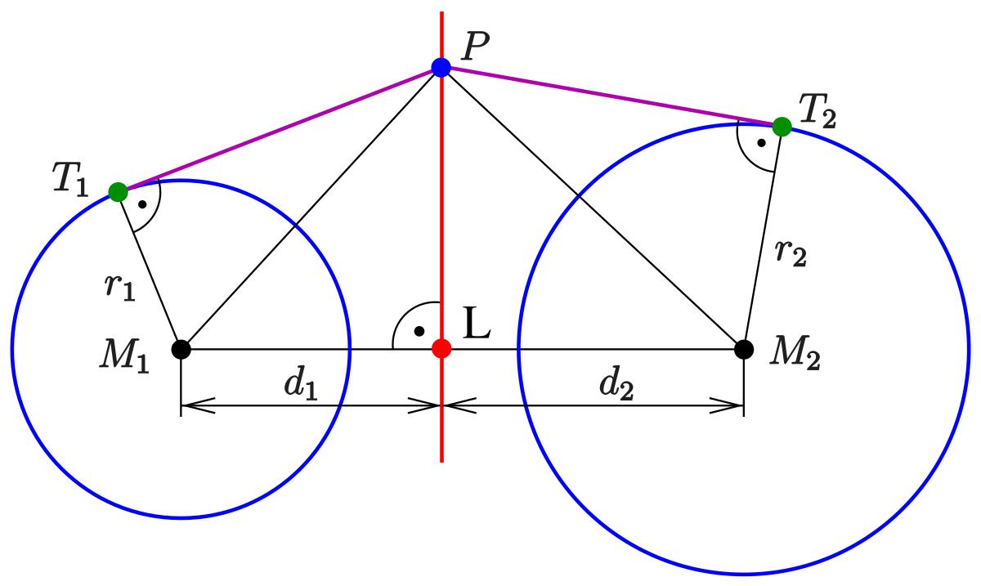
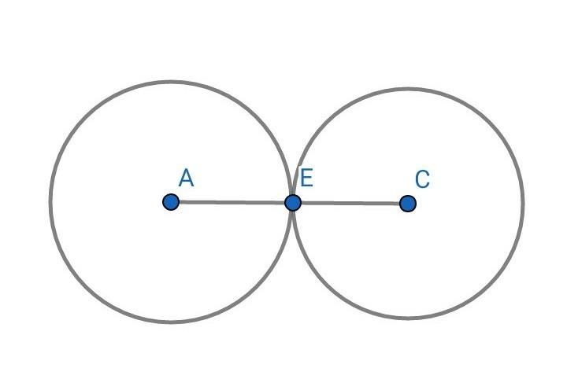

Coordinate Geometry
# Source: AI Source: Provided by: [Data Path: Persons Table -> ID Column: 1, Name_En Column: Motasem Essam] -> From: [ChatGPT] on [7/25/2026]
If the centers are:
$$O_{1}\left(x_{1} , y_{1}\right)$$
and:
$$O_{2}\left(x_{2} , y_{2}\right)$$
then their distance is:
$$d=\sqrt{{\left(x_{2}-x_{1}\right)}^{2}+{\left(y_{2}-y_{1}\right)}^{2}}$$
For external tangency:
$$\boxed{\sqrt{{\left(x_{2}-x_{1}\right)}^{2}+{\left(y_{2}-y_{1}\right)}^{2}}=R_{1}+R_{2}}$$

Tangency Point Coordinates
# Source: AI Source: Provided by: [Data Path: Persons Table -> ID Column: 1, Name_En Column: Motasem Essam] -> From: [ChatGPT] on [7/25/2026]
For external tangency, the tangency point divides the line segment between the centers according to the radii.
If:
$$O_{1}=\left(x_{1} , y_{1}\right)$$
and:
$$O_{2}=\left(x_{2} , y_{2}\right)$$
then:
$$\boxed{T=\left(\frac{R_{2}x_{1}+R_{1}x_{2}}{R_{1}+R_{2}} , \frac{R_{2}y_{1}+R_{1}y_{2}}{R_{1}+R_{2}}\right)}$$
This gives the point where the two externally tangent circles touch.

Tangent-Length Relationship
# Source: AI Source: Provided by: [Data Path: Persons Table -> ID Column: 1, Name_En Column: Motasem Essam] -> From: [ChatGPT] on [7/25/2026]
Suppose an external point $P$is connected to the tangency point $T$of two circles. The relevant tangent-length relationships can be determined using the right triangles formed by the radii and tangent lines.
For any circle with center $O$, radius $R$, and external point $P$:
$$\boxed{PT=\sqrt{PO^{2}-R^{2}}}$$
when $PT$is a tangent segment.

External Tangency and Homothety
# Source: AI Source: Provided by: [Data Path: Persons Table -> ID Column: 1, Name_En Column: Motasem Essam] -> From: [ChatGPT] on [7/25/2026]
Two externally tangent circles have a special homothety relationship.
Their external tangency point $T$lies on the line joining their centers and serves as a center of internal homothety.
This is an advanced geometric interpretation of external circle–circle tangency.

Important Properties
# Source: AI Source: Provided by: [Data Path: Persons Table -> ID Column: 1, Name_En Column: Motasem Essam] -> From: [ChatGPT] on [7/25/2026]
- The circles lie outside one another.
- They have exactly one common point.
- The common point is the external tangency point.
- The centers and tangency point are collinear.
- The distance between centers equals the sum of the radii:
$$\boxed{O_{1}O_{2}=R_{1}+R_{2}}$$
- The common tangent at the tangency point is perpendicular to the line joining the centers.
- The tangency point lies between the two centers.
- Equal externally tangent circles have center distance $2R$.
- Each circle has a radius extending from its center to the same tangency point.
- External tangency is the boundary case between separated circles and two-intersection configurations.

Classification
# Source: AI Source: Provided by: [Data Path: Persons Table -> ID Column: 1, Name_En Column: Motasem Essam] -> From: [ChatGPT] on [7/25/2026]
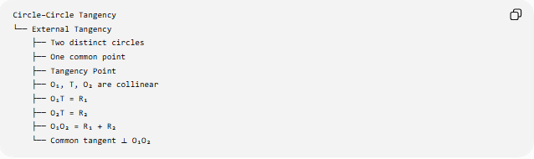
Circle–Circle Tangency
└── External Tangency
├── Two distinct circles
├── One common point
├── Tangency Point
├── O₁, T, O₂ are collinear
├── O₁T = R₁
├── O₂T = R₂
├── O₁O₂ = R₁ + R₂
└── Common tangent ⟂ O₁O₂

Key Formulas
# Source: AI Source: Provided by: [Data Path: Persons Table -> ID Column: 1, Name_En Column: Motasem Essam] -> From: [ChatGPT] on [7/25/2026]
External Tangency Condition
$$\boxed{d=R_{1}+R_{2}}$$
Center Distance
$$\boxed{d=\sqrt{{\left(x_{2}-x_{1}\right)}^{2}+{\left(y_{2}-y_{1}\right)}^{2}}}$$
Radii to Tangency Point
$$\boxed{O_{1}T=R_{1}} \\ \boxed{O_{2}T=R_{2}}$$
Collinearity
$$\boxed{O_{1}, T, O_{2}\text{ are collinear}}$$
Common Tangent
$$\boxed{l⊥O_{1}O_{2}}$$

Key Points
# Source: AI Source: Provided by: [Data Path: Persons Table -> ID Column: 1, Name_En Column: Motasem Essam] -> From: [ChatGPT] on [7/25/2026]
- External Tangency means two circles touch from the outside.
- They have exactly one common point.
- The tangency point lies between the two centers.
- The centers and tangency point are collinear.
- The center distance equals the sum of the radii.
- The common tangent at the contact point is perpendicular to the line joining the centers.
$$\boxed{\text{External Tangency }⟺ O_{1}O_{2}=R_{1}+R_{2}}$$

Conclusion
# Source: AI Source: Provided by: [Data Path: Persons Table -> ID Column: 1, Name_En Column: Motasem Essam] -> From: [ChatGPT] on [7/25/2026]
External Tangency is the case in which two circles touch externally at exactly one point. Its defining geometric relationship is that the distance between the centers equals the sum of the radii, while the two centers and the tangency point lie on the same straight line.

